A000-China-Hongshan-Disc-3 Notches-Xuanji-Hsuan chi-Jade-3500-2200 BCE

Ancient Ancestor Notched Jade Disk

English Translation of Ancient Characters

Hongshan Culture

c. 3500 BC—2200 BC

This Immortal Jade Immortality Amulet (a type called Xuanji in Chinese) is in Good ancient condition for being over 4,000 years old. This Neolithic Chinese Heaven Pendant/Amulet is made of pure, Nephrite Jade that has turned a fantastic shade of orange. No major chips, cracks, repairs, or restorations. Only heavy, natural pitting, surface scratches, calcification and differential weathering & pitting.

SUMMARY

This ceremonial Jade Disc is a ritual Astronomical Disk (Hsuan Chi or Xuanji in Chinese) and dates approximately to the Hongshan Culture of ancient China, 3500 BC to 2200 BC.  It measures approximately 4.12” (105 mm) in diameter x .26” (6.7 mm) thick.  It has the period correct cone-shaped hole in the center that measures 13 mm in diameter.  The solid nephrite jade disk weighs 4.0 oz. (113 gr.) and shows heavy pitting and differential weathering from its burial in damp soil for thousands of years.

The jade disk is believed to have been a precious religious and/or ceremonial object that was offered as a sacrifice to the Ancestors of the deceased in hopes that they would guide the soul of the deceased into eternal life in Heaven.  Jade artifacts like this one were often buried in tombs with the deceased.  The notched disk is thought to represent three stars in the Little Dipper (Ursa Minor). The star at the end of the Little Dipper handle is Polaris, the North Star and the brightest in the sky.  The "Shu Ching" says it is the instrument for observing the constellations and that this jade instrument can be rotated when viewing the Heavens.

The central hole was seen as a window to the Heavens, Ancestors, and Gods (“Shên” in Chinese).  There are several very small Chinese characters that were carved around the center hole in a circular fashion.  This disk served as an oracle or portal to one’s Ancestors in Heaven, in Chinese “Ti’en.”  This amazing jade disc also features three, deep notches on the outer edge of the disc that symbolize “Heaven, Earth, and Man.”

English Translation of Characters

When this jade disk was professionally cleaned in China to remove excessive weathering, it exposed dozens of ancient characters that were cut into the jade. Both sides of this jade disk have several wonderful ancient Chinese pictographic characters that predate the Ku-wen or “Large Seal Script” of a thousand years later.  The pictographic characters are very small and measure from 4 mm to 12 mm tall.  The characters are not in columns or rows, but rather are in a circular pattern around the center hole—the portal for the prayers to enter Heaven.

Although this disc shows signs of extreme pitting and weathering, if you look carefully at the 4x macro photos and especially under 10x magnification, you will see various small characters that have been cut into the jade in low relief.  There are many ancient Chinese characters/pictographs, including those of:  ancestors, offering of animal sacrifices, a son’s offering for his father, an offering of wine and meat to the ancestors, temples, the presentation of a new-born child in the sight of an ancestor, libations of wine, and other offerings to the ancestors and gods.

Ancestors are depicted with circular or elongated heads with an eye in the center and a “Ω“ figure that is the Chinese character for a “cloud”—which is the home of the Ancestors.  The ghost-like Ancestors have the character “Ch’iao” in the center of the “Ω“ that is a bent center line down the middle with 2 and 4 horizontal lines (respectively) on each center line.  This character represents an Ancestor who is having trouble breathing—thus is dead.  The ancient Chinese thought that once a person stopped breathing his soul had temporarily left the person body and the departed soul could be lured back to the body if appropriate sacrifices of food, water, jade, and bronze were made. The Ancestor characters are a clear and powerful reference to the spirit world of the departed souls and of the Ancestors. {REF: E.T.C. Werner, Myths and Legends of China, Chapter IV, The Gods of China; and Dr. Wieger, pg. 27}

Experts suggest that these ancestors are looking with benevolence at the offering of this lovely jade disc that has been offered as a sacrifice to honor them so that they may help the soul of the departed into the next world.

DETAILS

Both sides of the Bi show signs of pitting and differential weathering, both accurate signs of being buried in the damp soil of China for over 5,000 years.  And look at the fantastic coloration of the once green nephrite jade that has turned a wonderful color of vibrant orange and brown from the iron and other elements and minerals in the soil that have absorbed into the porous jade over 5,000 years.  As noted above, the disk has been professionally cleaned in China in order to show the beauty of the jade and to expose the very tiny characters that had been carved into it.  This disk is a stunning, museum quality example of Neolithic Chinese art that displays magnificently and would look great in your collection!

At 4.12” in diameter, this is an exceptionally large disk and would only have been a gift to the Ancestors from a very wealthy and powerful person in ancient China. Such ritual gifts or sacrifices were left in the tombs of the departed or at shrines or temples on the surface near the tomb.  The ancient Chinese believed that such gifts would please the Ancestors, who could affect events in Heaven and on Earth, and protect them from Evil Spirits and Demons (“Kuei” in Chinese) who were thought to inhabit both worlds.

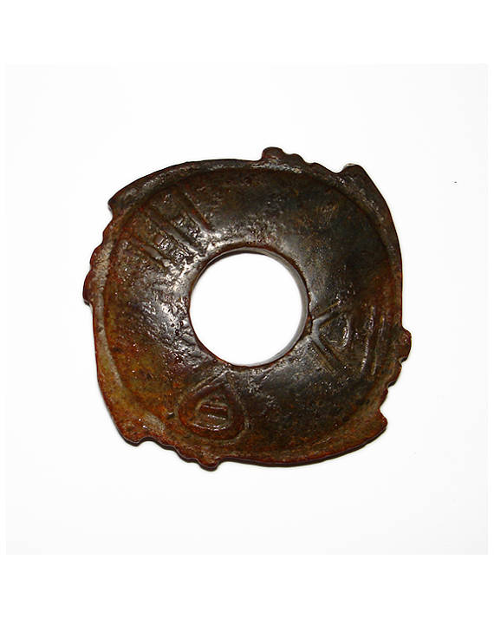

4 notches with 3 serrations

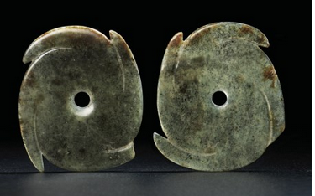

###### Lot 105

# A PAIR OF VERY RARE GREEN JADE NOTCHED DISCS, *YABI*

## NEOLITHIC PERIOD, CIRCA 2000 BC

Price realised GBP 1,875

Estimate GBP 1,500 - GBP 2,500

Add to Interests

A PAIR OF VERY RARE GREEN JADE NOTCHED DISCS, *YABI*   
NEOLITHIC PERIOD, CIRCA 2000 BC   
The exceptionally thin discs of oval shape, each carved representing a swirl with four notches in clockwise or anti-clockwise direction, the centre with a small circular aperture, the stone of dark green tone suffused with black flecks  
2½ in. (6 cm.) wide, box (2)

##### Contact Client Service

* [info@christies.com](mailto:info@christies.com)
* New York +1 212 636 2000
* London +44 (0)20 7839 9060
* Hong Kong +852 2760 1766
* Shanghai +86 21 6355 1766

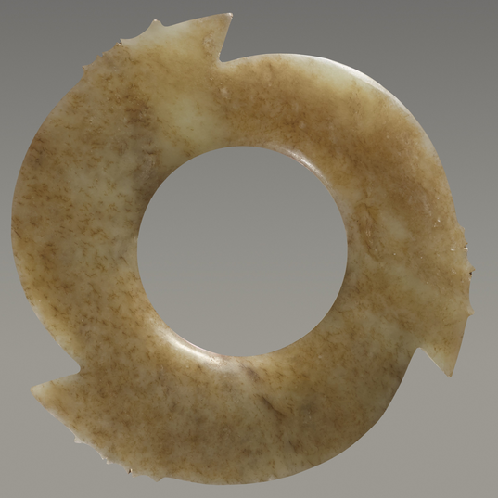

[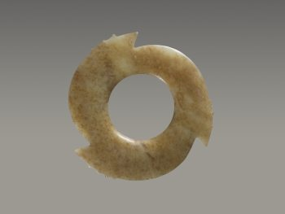](https://www.zacke.at/sites/default/files/styles/artobject_huge/public/artobjects/JAK0917-011.jpg?itok=-XhVaZWq)

[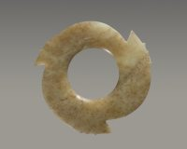](https://www.zacke.at/sites/default/files/styles/artobject_huge/public/artobjects/JAK0917-011A.jpg?itok=DC2qUt-Y)

[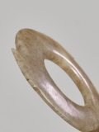](https://www.zacke.at/sites/default/files/styles/artobject_huge/public/artobjects/JAK0917-011B.jpg?itok=tA58gaGi)

[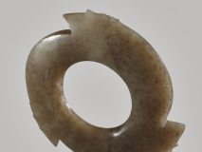](https://www.zacke.at/sites/default/files/styles/artobject_huge/public/artobjects/JAK0917-011C.jpg?itok=NaSMzdZk)

A FASCINATING YABI, OR NOTCHED DISC, WITH THREE POINTED PROTRUSIONS ENRICHED WITH THIN AND DELICATELY CARVED NOTCHES

Catalog Number: JAK0917-011

Jade

China

Late Neolithic, early Bronze Age, Longshan culture, c.2600-1900 BC 玉牙璧精品 - 新石器時代晚期, 青銅時代早期,龍山文化, 約公元前 2600-1900年

DIAMETER: 9.3 CM, DIAMETER OF INNER HOLE: 4.3 CM, THICKNESS: 0.94 CM 直徑 9.3 厘米，內孔直徑 4.3 厘米，厚 0.94 厘米

Notched discs form a unique category of jades crafted in late Neolithic, early Bronze Age China and are mostly associated with the Longshan culture. They are likely descended from earlier prototypes, since small circular ornaments worked in similar shapes have been discovered in sites of the Hongshan culture (c.3500-2500 BC).

This intriguing disc has an almost pinwheel shape due to the way in which the three projections with smaller notches near the tips were carved. The immediate, strong impact is due to the striking shape of the object: each of the three notches is adorned with a series of small, regular indentations that look, and feel, like teeth of a saw. No additional decorative motifs are carved on the disc, whose smooth, convex surfaces slope gently towards the inner central hole and outer perimeter.

The light green jade presents some black speckles and numerous mottled rust coloured dots throughout. The notched disc seems opaque, but when held to the light it is actually quite translucent, except for the coloured areas where the iron contained in the jade blocks the light.

Literature comparison/Archaeological sites: Notched discs with similar crenellations are in the Samuel and Myrna Myers collection, see J.P. Desroches (ed.), Two Americans in Paris. A Quest for Asian Art, Paris 2016, nos.77, 81, 83. See also F. Salviati, 4000 Years of Chinese  
Archaic Jades, Edition Zacke, Vienna 2017, no.94-96. Two further examples in the Harvard Art Museums, accession numbers 1943.50.530/532, are published in M. Loehr and L.G. Fitzgerald Huber, Ancient Chinese Jades from the Grenville L. Winthrop Collection in the Fogg Art Museum, Harvard University, Fogg Art Museum (Cambridge, MA) 1975, nos.106-107.

Expertise:

Prof. Dr. Filippo Salviati

From a Luxembourg collection  
盧森堡舊藏

All jades in this catalogue have been professionally examined, authenticated and described by Prof. Fillipo Salviati. Professor Salviati teaches Chinese and Korean art at Sapienza University in Rome, in the Italian Institute of Oriental Studies. He is a world expert on archaic Chinese jades, having released multiple publications and being cited by renowned auction houses such as Sotheby’s.

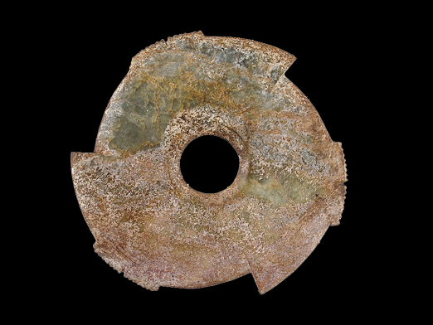

<http://www.ciajg.pt/_xuan_ji_2> . 3 notches with 14 serrations in 2 groups of 7

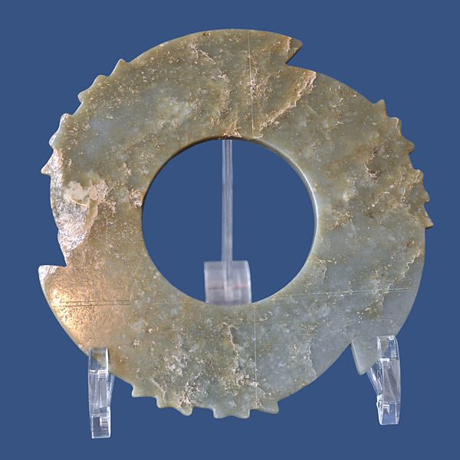

Ritual disc Xianji, jade, Neolithic 3000 BC (?), China. Royal Museums of Art and History (MRAH), Jubilee Park, Brussels. 3 notches, 6 serrations in 2 groups of 3

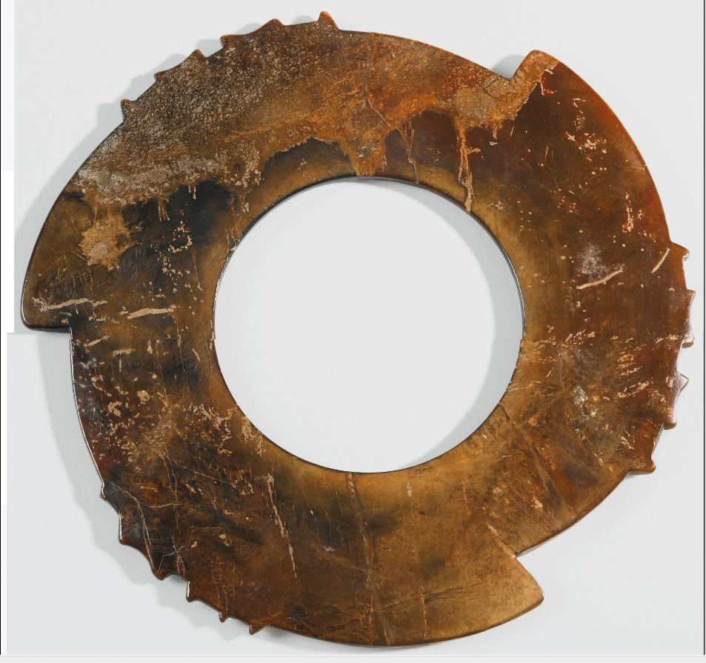



3 notches 6 serrations in 2 groups of 3

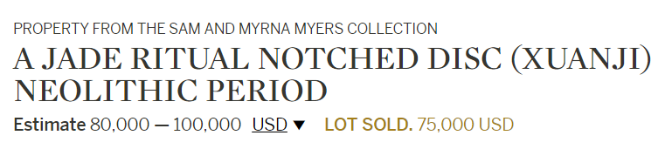

##### \

##### 25.

##### 25. A JADE NOTCHED DISC (*YABI*)

Late Neolithic Period/ Shang Dynasty, *circa* 2000 – 1500 B.C.

with wide central circular aperture, the narrow flat sides carved as three conjoined arcs, each rising to a wedge shaped point and with pairs of blunt notched teeth carved on each of the three arcs, all evenly spaced and symmetrically arranged around the outer rim, the inner rim plain and simply rounded, the pale grayish-white jade encrusted with cinnabar and burial earth.

Diameter 4 1⁄4 inches (10.8 cm)

This rare type of *bi*disc with notched and serrated rim was identified as a *xuanji*(璇璣) by the Chinese scholar-collector Wu Dacheng in his description of a similar notched disc illustrated in the catalogue of his collection, the *Gu yu tu kao*, published in 1889. Wu’s identification was based on his interpretation of a section of the *Shangshu*(Classic of History), a pre-Qin dynasty text containing a reference to a turning sphere (*xuanji* 璇璣) to be used in conjunction with a jade transverse sighting tube (*yuheng* 玉衡) for astronomical observations by court astronomers. This identification and description of the use of ancient jade notched discs was widely accepted and elaborated upon by Chinese and Western scholars during the following decades, but no archaeological evidence to support the theory has ever been found. Modern scholars, led by Xia Nai, have repudiated the theory and argued convincingly for the term *xuanji*to be abandoned and replaced by the term *yabi* (牙璧). See “The Classification, Nomenclature, and Usage of Shang Dynasty Jades” by Xia Nai, published in ***Kaogu*, 1983, No. 5**, pp. 455-467. The same monograph was presented by Xia at the International Conference on Shang Civilization, Hawaii, 1982, and is published in English by Chang (ed.), *Studies of Shang Archaeology*, New Haven, 1986, Chapter 9, pp. 207-236.

A slightly smaller jade *yabi*, with pairs of blunt notched teeth carved on each of the three arcs, excavated from a Longshan Culture (*circa*3000-1700 B.C.) site at Tengxian, Shandong province, is illustrated by Xia, ***Kaogu xuebao*, 1984, No. 4, pl. 2:1,** with a stone example from a late Shang burial at Anyang, Henan province, *loc. cit*., pl. 1. The same jade *yabi*is illustrated in color in *Zhongguo yuqi quanji*(Compendium of Chinese Jades), Vol. 1, *Primitive Society*, Shijiazhuang, 1992, p. 34, col. pl. 42.

Another similar jade *yabi* in the collection of the **Palace Museum, Beijing** is illustrated in*Gugong bowuyuan cang wenwu zhenpin quanji*(The Complete Collection of Treasures of the Palace Museum), *Jadeware* (I), Hong Kong, 1995, p. 58, no. 49; and another similar *yabi*in the collection of the Kaifeng Museum is illustrated by Gu (ed.), *Zhongguo chuanshi yuqi quanji*(Chinese Jades in Traditional Collections), Vol. 1, *Neolithic Period, Shang, Western Zhou, Spring and Autumn Period, Warring States Period*, Beijing, 2010, p. 84.

Compare also the *yabi* of similar form in the Arthur M. Sackler Gallery, Washington D.C., illustrated in *Asian Art in the Arthur M. Sackler Gallery, The Inaugural Gift*, Washington, D.C., 1987, p. 89, no. 45; another illustrated by Loehr, *Ancient Chinese Jades from the Grenville L. Winthrop Collection in the Fogg Art Museum, Harvard University*, Cambridge, 1975, p. 103, no. 106; and another closely related jade *yabi* in the British Museum, illustrated by Rawson, *Chinese Jade from the Neolithic to the Qing*, London, 1995, p. 163, pl. 8:1.

For a comprehensive discussion of *yabi*discs excavated in China, see **Luan, “Yabi yanjiu (Researches on *Yabi*),” *Wenwu*, 2005, No. 7, pp. 69-81.**

新石器時代晚期  /  商   玉牙璧   徑 10.8 厘米

**AN IMPRESSIVE EARLY BRONZE AGE NOTCHED DISC IN GREEN JADE**

Katalognummer: JAK0318-012

Jade

China

Early Bronze Age, ca 2200-1600 BC 玉牙璧 - 青銅器時代早期公元前 2200-1600年

WIDTH 22 CM 寬 22 厘米

Notched discs (called yabi 牙璧 in Chinese, or ‘toothed discs’) form a particular yet little understood category of jades that were crafted in the late Neolithic and early Bronze Age periods. These discs, derived from earlier and smaller Neolithic prototypes, are usually provided with three protrusions carved at regular distances around the border, each accompanied by a group of notches. Instead, the present, quite substantial example is carved with four indentations, a feature rarely seen on notched discs but known through other examples, such as a few yabi in the National Palace Museum collection, in Taipei, Taiwan.

The present notched disc is carved from a beautiful variety of green jade: the polished and quite smooth surface presents considerable alterations, especially in the areas along the edge, and many mottled patches of beige and light brown. The central hole is smooth and slightly rounded, while the surface and edges are a bit irregular, with some chips along the outer edge.

One of the above-mentioned discs with four notches in the National Place Museum in Taipei is illustrated in Gugong gu yu tu lu 故宫古玉圖錄 (Illustrated Catalogue of Ancient Jade Artefacts), National Palace Museum, Taipei 1988, no.217. A yabi of equal size but carved more roughly and with only three large projections was found in 1989 in a late Neolithic site at Dantu, Wulian county, Shandong province.

--------------------------------------------------------------------------------------------------------------------- 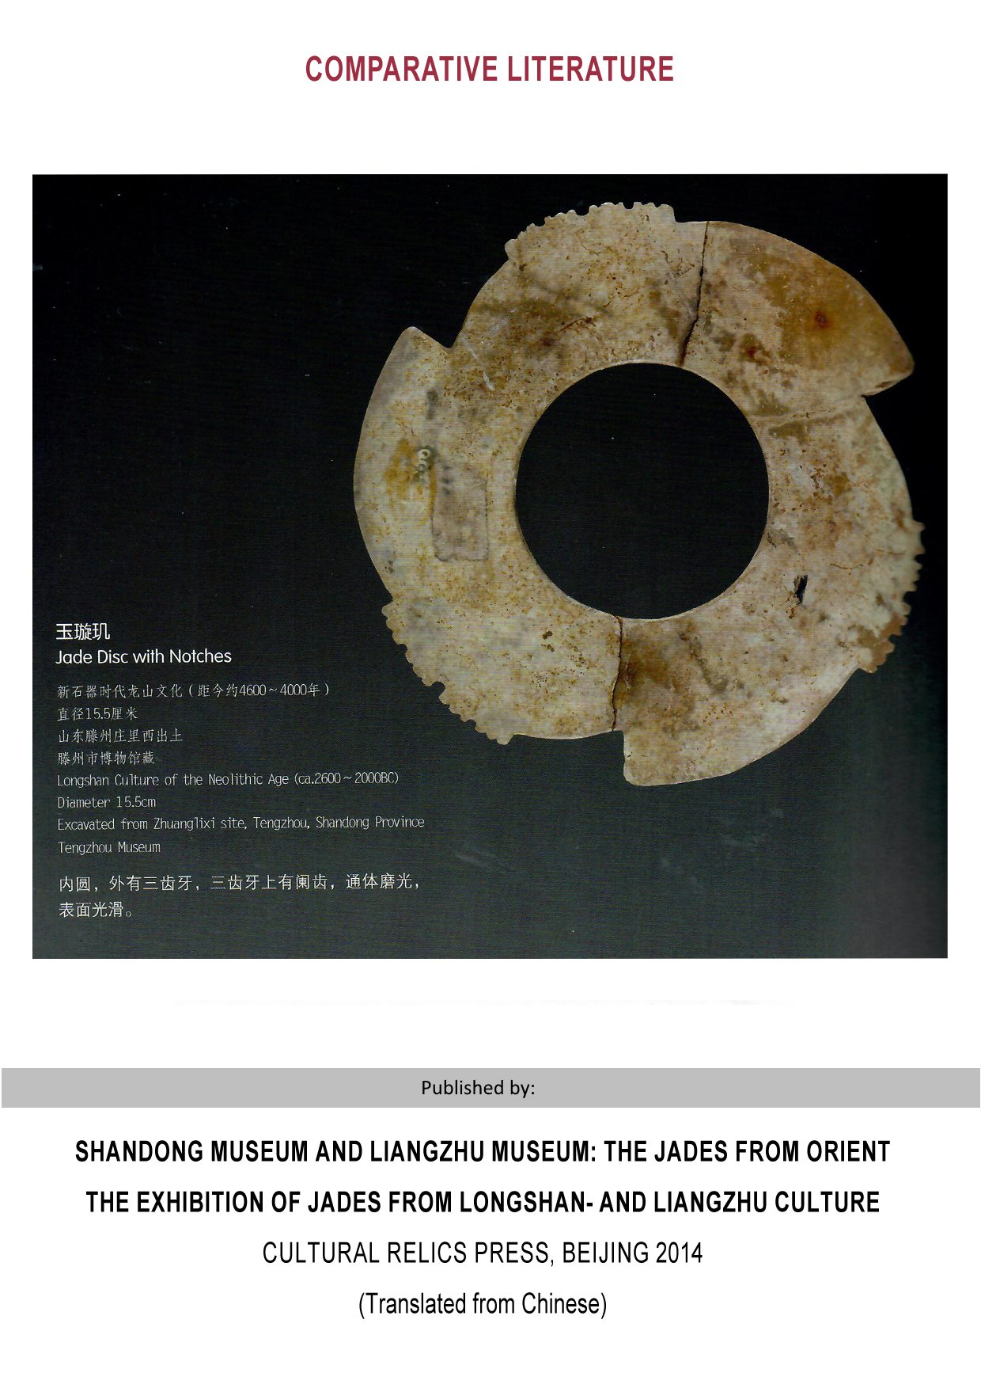 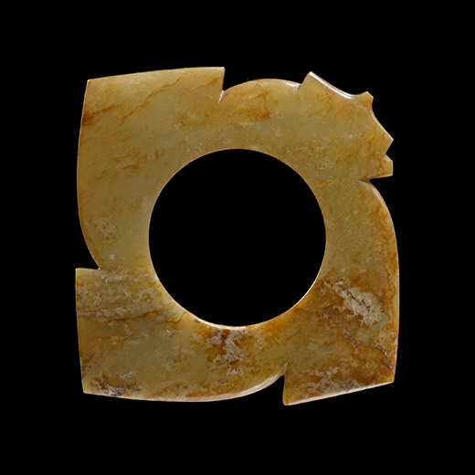

A NEOLITHIC JADE NOTCHED DISC (YABI)  
circa 2500-2000 B.C.  
Diameter 6 inches (15.2 cm)

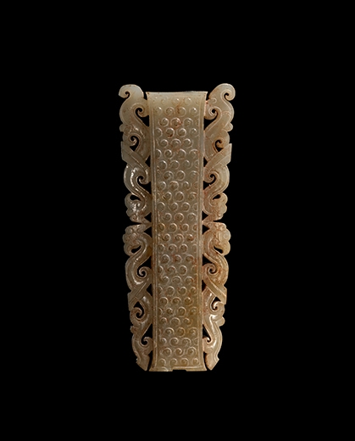

AN ARCHAIC JADE OPENWORK LONG PENDANT  
Eastern Zhou Dynasty, circa 5th-4th Century B.C.  
Length 3 3/8 inches (8.6 cm)

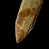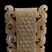[Exhibits](http://www.asiaweekny.com/dealers/j-j-lally-co#exhibits)

## **‹**

[CHINESE ART](http://www.asiaweekny.com/dealers" \l "1)

http://www.asiaweekny.com/sites/asiaweekny/files/profilelogo-lally.png

41 East 57th Street  
Suite 1400  
New York 10022

T (212) 371 3380  
  
[staff@jjlally.com](mailto:staff@jjlally.com)  
[jjlally.com](http://www.jjlally.com/)

Facebook, Instagram: @jjlallynyc  
WeChat: JJLally

# Lot 11 - A FASCINATING YABI, OR NOTCHED DISC, WITH THREE POINTED PROTRUSIONS ENRICHED WITH THIN AND

## Result of the bid through subscription

[> Check Premium offers](https://www.auction.fr/_en/abonnement/)

Powered by [[Google Translate](https://translate.google.com/)Translate](https://translate.google.com)

* [Description of the lot](https://www.auction.fr/_en/lot/a-fascinating-yabi-or-notched-disc-with-three-pointed-protrusions-enriched-with-thin-and-12426849#.WqGGm3xOldg)

A FASCINATING YABI, OR NOTCHED DISC, WITH THREE POINTED PROTRUSIONS ENRICHED WITH THIN AND DELICATELY CARVED NOTCHES  
Jade. China, Late Neolithic, early Bronze Age, Longshan culture, c.2600-1900 BC  
玉牙璧精品 - 新石器時代晚期, 青銅時代早期,龍山文化, 約公元前 2600-1900年  
  
DIAMETER: 9.3 CM, DIAMETER OF INNER HOLE: 4.3 CM, THICKNESS: 0.94 CM  
直徑 9.3 厘米，內孔直徑 4.3 厘米，厚 0.94 厘米  
  
Notched discs form a unique category of jades crafted in late Neolithic, early Bronze Age China and are mostly associated with the Longshan culture. They are likely descended from earlier prototypes, since small circular ornaments worked in similar shapes have been discovered in sites of the Hongshan culture (c.3500-2500 BC).  
  
This intriguing disc has an almost pinwheel shape due to the way in which the three projections with smaller notches near the tips were carved. The immediate, strong impact is due to the striking shape of the object: each of the three notches is adorned with a series of small, regular indentations that look, and feel, like teeth of a saw. No additional decorative motifs are carved on the disc, whose smooth, convex surfaces slope gently towards the inner central hole and outer perimeter.  
  
The light green jade presents some black speckles and numerous mottled rust coloured dots throughout. The notched disc seems opaque, but when held to the light it is actually quite translucent, except for the coloured areas where the iron contained in the jade blocks the light.  
  
Literature comparison/Archaeological sites: Notched discs with similar crenellations are in the Samuel and Myrna Myers collection, see J.P. Desroches (ed.), Two Americans in Paris. A Quest for Asian Art, Paris 2016, nos.77, 81, 83. See also F. Salviati, 4000 Years of Chinese  
Archaic Jades, Edition Zacke, Vienna 2017, no.94-96. Two further examples in the Harvard Art Museums, accession numbers 1943.50.530/532, are published in M. Loehr and L.G. Fitzgerald Huber, Ancient Chinese Jades from the Grenville L. Winthrop Collection in the Fogg Art Museum, Harvard University, Fogg Art Museum (Cambridge, MA) 1975, nos.106-107.  
  
Expertise: Prof. Dr. Filippo Salviati  
  
From a Luxembourg collection  
盧森堡舊藏   
  
All jades in this catalogue have been professionally examined, authenticated and described by Prof. Fillipo Salviati. Professor Salviati teaches Chinese and Korean art at Sapienza University in Rome, in the Italian Institute of Oriental Studies. He is a world expert on archaic Chinese jades, having released multiple publications and being cited by renowned auction houses such as Sotheby’s.  
  
  
A FASCINATING YABI, OR NOTCHED DISC, WITH THREE POINTED PROTRUSIONS ENRICHED WITH THIN AND DELICATELY CARVED NOTCHES  
Jade. China, Late Neolithic, early Bronze Age, Longshan culture, c.2600-1900 BC  
玉牙璧精品 - 新石器時代晚期, 青銅時代早期,龍山文化, 約公元前 2600-1900年  
  
DIAMETER: 9.3 CM, DIAMETER OF INNER HOLE: 4.3 CM, THICKNESS: 0.94 CM  
直徑 9.3 厘米，內孔直徑 4.3 厘米，厚 0.94 厘米  
  
Notched discs form a unique category of jades crafted in late Neolithic, early Bronze Age China and are mostly associated with the Longshan culture. They are likely descended from earlier prototypes, since small circular ornaments worked in similar shapes have been discovered in sites of the Hongshan culture (c.3500-2500 BC).  
  
This intriguing disc has an almost pinwheel shape due to the way in which the three projections with smaller notches near the tips were carved. The immediate, strong impact is due to the striking shape of the object: each of the three notches is adorned with a series of small, regular indentations that look, and feel, like teeth of a saw. No additional decorative motifs are carved on the disc, whose smooth, convex surfaces slope gently towards the inner central hole and outer perimeter.  
  
The light green jade presents some black speckles and numerous mottled rust coloured dots throughout. The notched disc seems opaque, but when held to the light it is actually quite translucent, except for the coloured areas where the iron contained in the jade blocks the light.  
  
Literature comparison/Archaeological sites: Notched discs with similar crenellations are in the Samuel and Myrna Myers collection, see J.P. Desroches (ed.), Two Americans in Paris. A Quest for Asian Art, Paris 2016, nos.77, 81, 83. See also F. Salviati, 4000 Years of Chinese  
Archaic Jades, Edition Zacke, Vienna 2017, no.94-96. Two further examples in the Harvard Art Museums, accession numbers 1943.50.530/532, are published in M. Loehr and L.G. Fitzgerald Huber, Ancient Chinese Jades from the Grenville L. Winthrop Collection in the Fogg Art Museum, Harvard University, Fogg Art Museum (Cambridge, MA) 1975, nos.106-107.  
  
Expertise: Prof. Dr. Filippo Salviati  
  
From a Luxembourg collection  
盧森堡舊藏

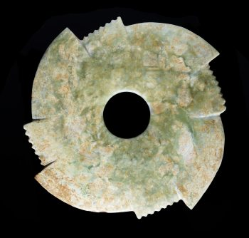

4 notches 7 serrations

**AN IMPRESSIVE EARLY BRONZE AGE NOTCHED DISC IN GREEN JADE**

Catalog Number: JAK0318-012

Jade

China

Early Bronze Age, ca 2200-1600 BC 玉牙璧 - 青銅器時代早期公元前 2200-1600年

WIDTH 22 CM 寬 22 厘米

Notched discs (called yabi 牙璧 in Chinese, or ‘toothed discs’) form a particular yet little understood category of jades that were crafted in the late Neolithic and early Bronze Age periods. These discs, derived from earlier and smaller Neolithic prototypes, are usually provided with three protrusions carved at regular distances around the border, each accompanied by a group of notches. Instead, the present, quite substantial example is carved with four indentations, a feature rarely seen on notched discs but known through other examples, such as a few yabi in the National Palace Museum collection, in Taipei, Taiwan.

The present notched disc is carved from a beautiful variety of green jade: the polished and quite smooth surface presents considerable alterations, especially in the areas along the edge, and many mottled patches of beige and light brown. The central hole is smooth and slightly rounded, while the surface and edges are a bit irregular, with some chips along the outer edge.

One of the above-mentioned discs with four notches in the National Place Museum in Taipei is illustrated in Gugong gu yu tu lu 故宫古玉圖錄 (Illustrated Catalogue of Ancient Jade Artefacts), National Palace Museum, Taipei 1988, no.217. A yabi of equal size but carved more roughly and with only three large projections was found in 1989 in a late Neolithic site at Dantu, Wulian county, Shandong province.

Expertise:

Prof. Filippo Salviati

From a German collection

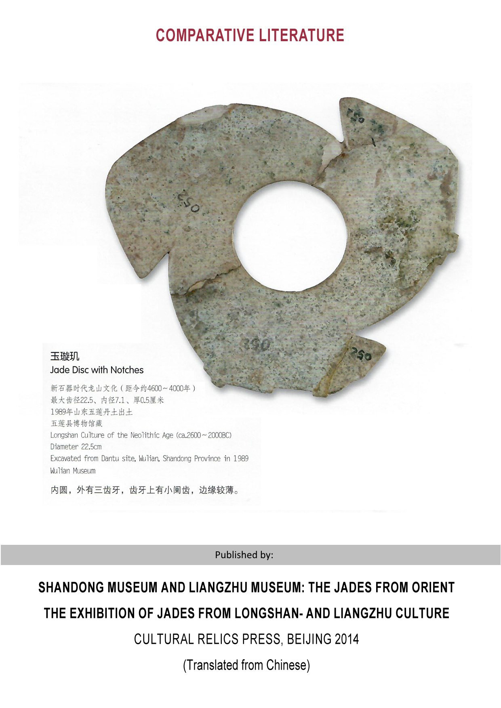



3 notches 12 serrations in 4 groups of 3